REACT NATIVE
1 ; 36 ; 41
REACT JS : rafce

REACT NATIVE : rnfe

NAMES OF PROJECT CONTEXT

TO COPY SHIFT + ALT THEN DOWN ARROW TO COPY IT DOWN
SHIFT + ALT THEN UP ARROW TO COPY UP

we were able to change a link to a button with the asChild property

for set up
$ npx create-expo-app@latest --template blank
to remove all the templates and to start from scratch

****TO START WITH ONLY CORE COMPONENTS *****
npx create-expo-app@latest CoreComponents –template blank@sdk-49

cd Core
***HOW TO RESET AFTER SETTING A PROJECT****

npm run reset-project

it will move the project to an /app-example

create app/index.tsx
app/_layout.tsx

****HOW TO DELELTE***
ie rm -rf folderName

rm -rf app-example

****GO TO THE tsconfig.json
"include" : [
under this "**/*.tsx",
"**/*.jsx",

*****CORE COMPONENTS ******
<view>
is a small rectangular element on the screen that can display text , images or respond
to user input

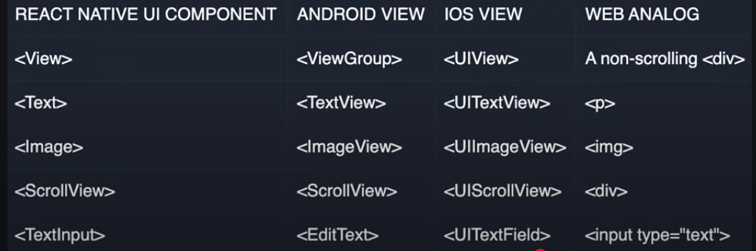

Note
When building with React Native
You import Elements Like
Import _{StyleSheet, Text, View } from “react-native”

****VIEW TAG******
This is a fundamental core component in React Native That aserves as a building
block for ceating user interfaces

In Web Development terms, the View component can be compared to the ‘<div>’
Tag

****WITHOUT THE VIEW TAG NOTHING WILL SHOW IN THE APP OR VIEW PAGE*****

**IMAGE COMPONENT ENABLES US TO DISPLAY VARIOUS TYPES OF IMAGES,
INCLUDING STATIC IMAGES, NETWORK IMAGES, IMAGES FROM LOCAL DISK,SUCH AS CARMERA ROLL

UIImageView for Ios
ImageView for Andriod
‘img’ for the web

****NOTE WITHOUT AN STYLE LET’S SAY HIEGHT OR WIDTH
THE IMAGE WILL NOT SHOW OR DISPLAY ********

Export default function App(){
Return (
<View style={{flex :1, backgroundColor :”plum”, padding : 60}}>
<Image source={logoImg} style={{width :300, height : 300 }} />
<Image
Source={{ uri : https://picsum.photos/300}}
Style={{ width : 300, height : 300 }}
/>
</View>
};
}

<ImageBackground source={logoImg} style={{flex : 1}}>
<Text> IMAGE TEXT </Text>
</ImageBackground>
</View>

******SCROLL VIEW *******
WITHOUT THE SCROLLL VIEW NOTHING WILL SCROLL
It wraps the platform-specific scrolling functionality
Requires a bounded height to function properly

This is what differneitaes web from app
The Scroll View Components without importing this from react-native the items will not scroll

You wrap the scroll view around the items you want to scroll

***BUTTON****

Import {View, Button } from “react-native”;

export default function App () {
return (
<View Style={{flex : 1, backgroundColor : “plum”, padding : 60 }}>
<Button
title=”Press”
onPress={ () => console.log (“Button Pressed”}}
color=”midnightblue”
disabled
/>
</View>

React onClick function
ReactNative Onpress

*********HOW TO HANDLE THE LOREM*****
IN YOUR HTML FILE
LOREM23 THEN PRESS TAB OR EQUALS TO

******PRESSABLE****
THIS IS A WRAPPER COMPONENT THAT DETECTS VARIOUS STAGES OF PRESS INTERACTIONS ON ITS DEFINED CHILDEREN

You can create a custom button using Pressable

onPressIn is called when a press Is activated
onLongPress is triggered when a press is held for longer than 500 milliseconds
onPressOut is called when the press gestures is deactivated

<View style={{ flex : 1, backgroundColor : "plum", padding : 60 }} >

<Button title="Press"onPress={ ()=> console.log("Button Pressed")} color="midnigtblue" />

<Pressable onPressOut={() => console.log("Image Pressed")}> //onPressIn or onPressOut or onLongPress
<Image
source={logoImg}
style={{ width: 'auto', height: 300 , margin : 0 }} // required
accessibilityLabel="titleImage"
/>
</Pressable>

*****MODAL*****
Modal is a screen that overlays the app content to provide important information or prompt the user for a decision

DIFFERENCES BETWEEN REACT AND REACT NATIVE

DIV = VIEW
P , H1, H2 – H9 = TEXT

CLASSNAME = STYLES = SYTLESHEET.CREATE({ CARD : { PADDING
BORDER RAIDUS : 8
onCLick = onPress
button = TouchableOpacity

REACT
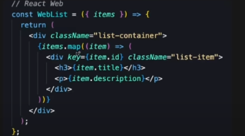
REACT NATIVE
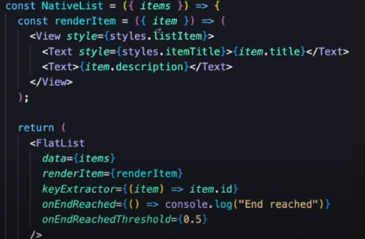

FORMS
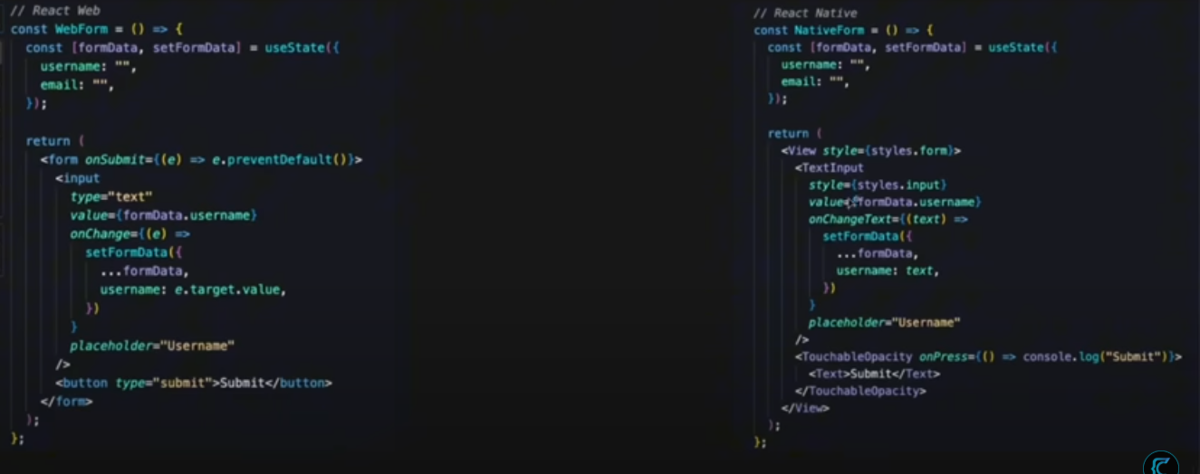

How to start
PS C:\Users\Great Okoro\Downloads\FULL STACK REACT NATIVE APP\mobile>
npm create-expo-app@latest

TO RESET
Npm run reset-project

HOW TO WIRTE SOURCE
<Image
source={require("@/assets/images/react-logo.png")}
style={{width : 300,
height: 300
}}/>

***********STACK COMPONENT*********
THE STACK COMPONENT THIS IS USED TO MAKE THE APP MOVE IN RIGHT WARD DIRECTION
WHY THE PREVIOUSLY OPENED IN LEFTWARD DIRECTION
<Stack />
return <Stack screenOptions = {{ headerShown : false }} />

****SAFE AREA VIEW****
NOTE EVERYTHING THAT HAPPENS ON THE SAFE AREA VIEW
IS SEEN BY REACT INSIDE THE PHONE
WITHOUT THIS ITEMS WILL NOT ALLIGN PROPERLY

*****FLEX AND DIFFERNENCE IN WEB AND APP DEVLOPEMENT*****
FLEX IS ROW DIRECTION BY DEFAULT
FLEX IS COLOUMN BY DEFAULT

****HOW TO USE CLERK****
GO TO CLERK WEBSITE
GO TO DASH BOARD
SCROLL DOWN TO CLIKC ON NATIVE APPLICATIONS
THEN ENSURE YOU ENABLE NATVE API

WEDNESDAY

1hr 37 mins started ended 1 hr 52 mins
11 : 34 AM

*****KEYBOARD AVOIDING VEIW ****
THIS IS USED TO AVOID THE KEY BOARD FROM OVERFOLLOWING THE TEXT AREA WHEN INPUTTING

****USE THIS TO FEEL THE WHOLE SCREEN WITH CONSISITENTEN BACKGTOUND COLOR****
backgroundColor: COLORS.background
IN
return (
<ClerkProvider tokenCache={tokenCache}>
<SafeAreaView style={{flex : 1, backgroundColor: COLORS.background}}>
<Slot />
</SafeAreaView>
</ClerkProvider>
);
}

****TO MAKE WINDOWS INSERT ALL IMPORTS****
CTRL + SHIT + P : It will bring out a panel then input reload window

*****NOTE WE ARE CREATING AN DYNAMIC PAGE*****
Ie the inputs inside will constantly be change
So we name the file like this [id].jsx
“id” can be anything : you can name it anything
const {id : recipeId} = useLocalSearchParams()
note the {id : } must bear the same with file [id].jsx
